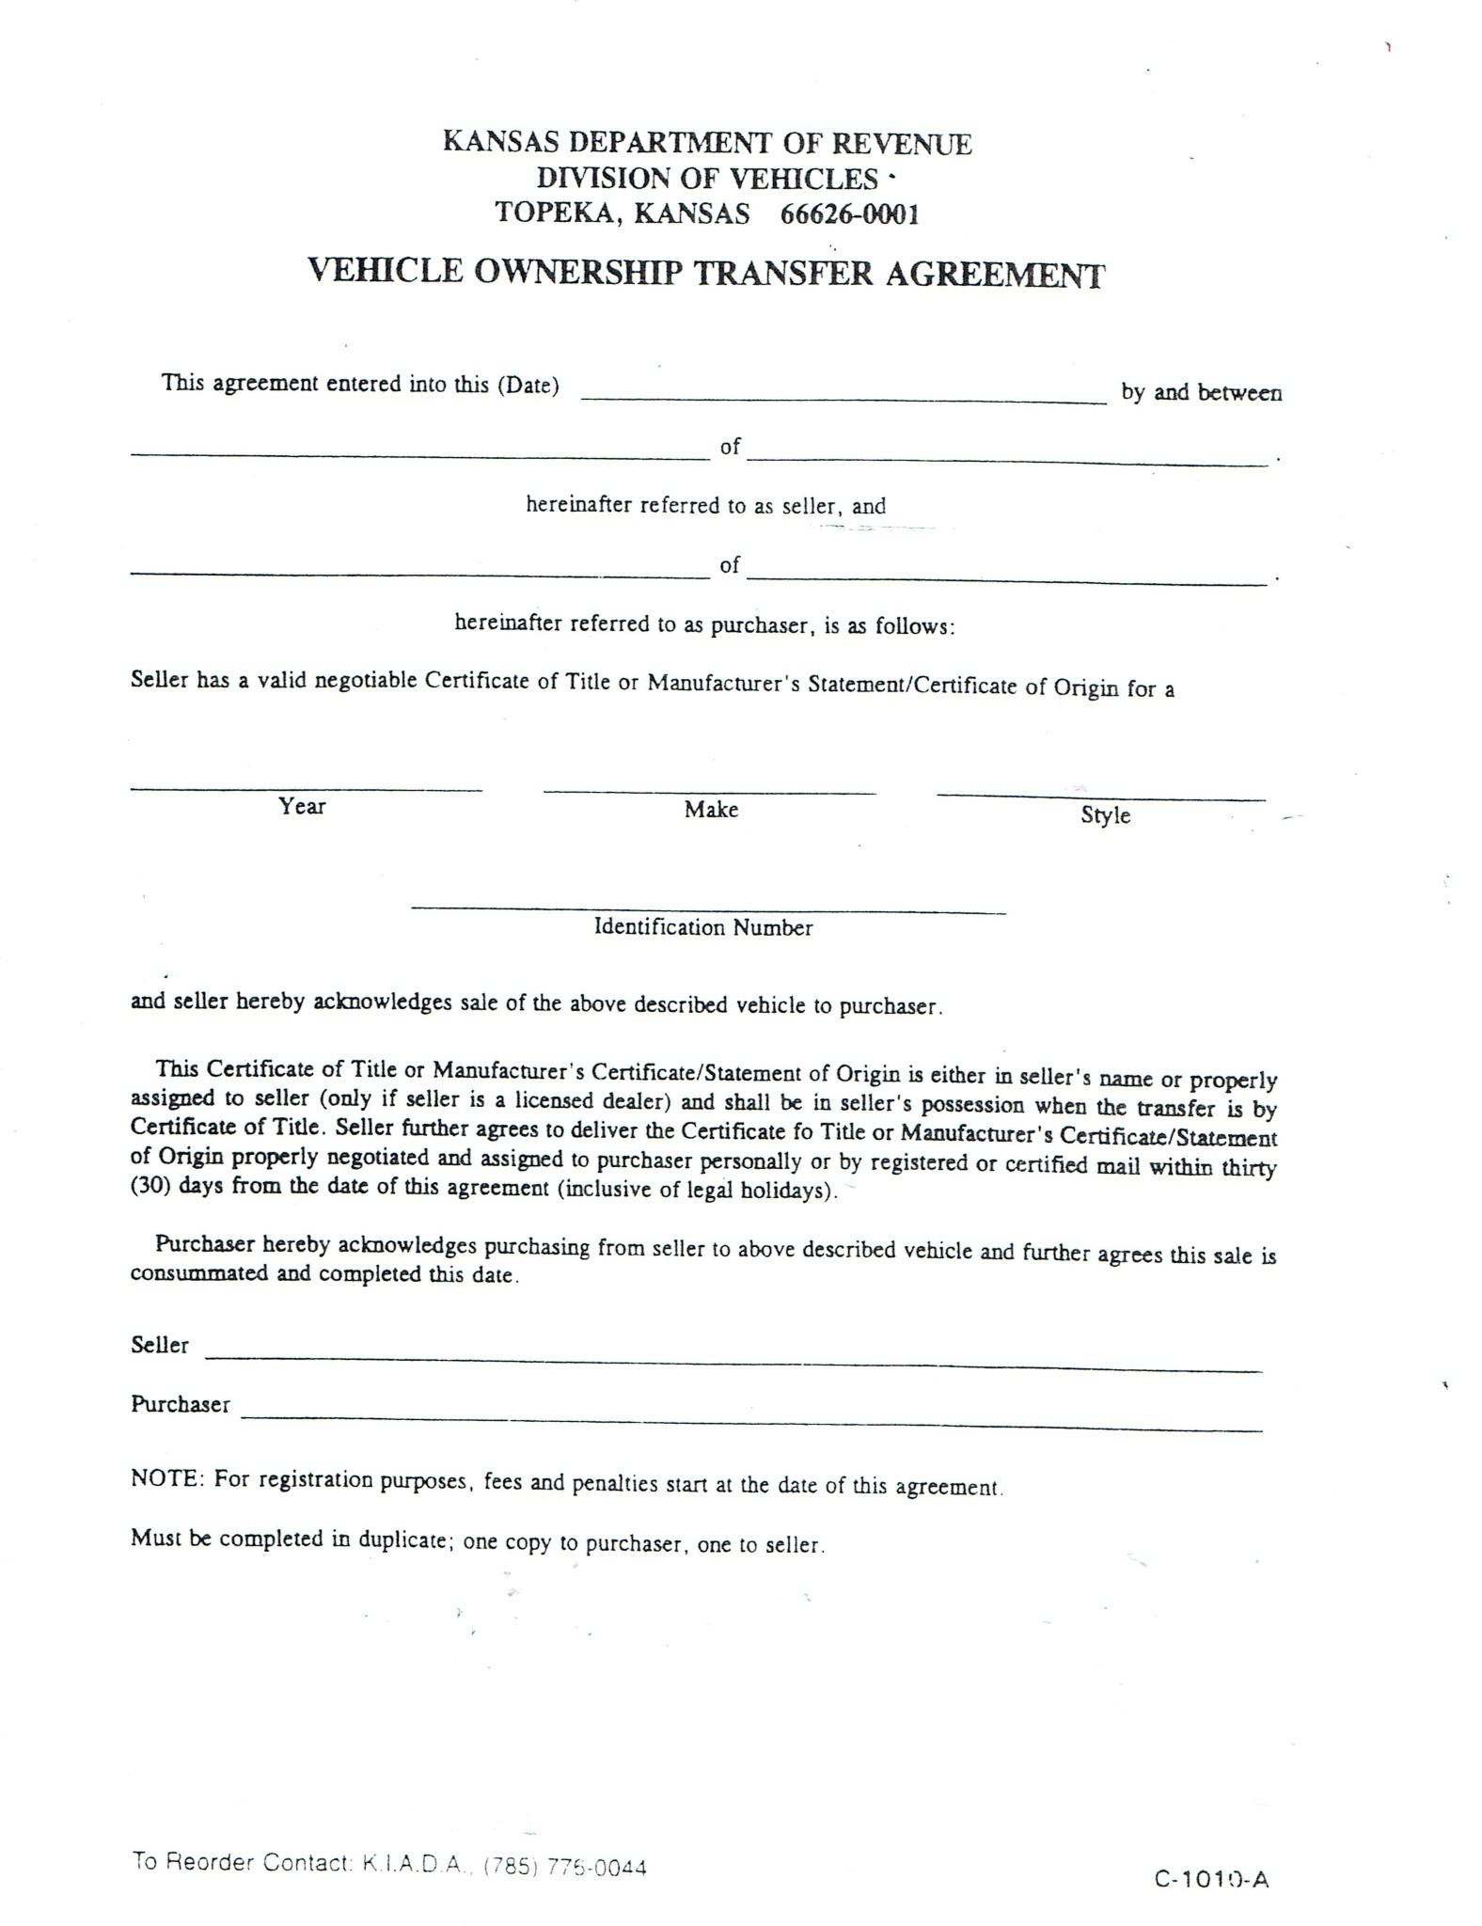

[VIN]

[Model]

[Make]

[Year]

[City-State]

[Buyer]

[Seller]

[Dealer]

[Date]